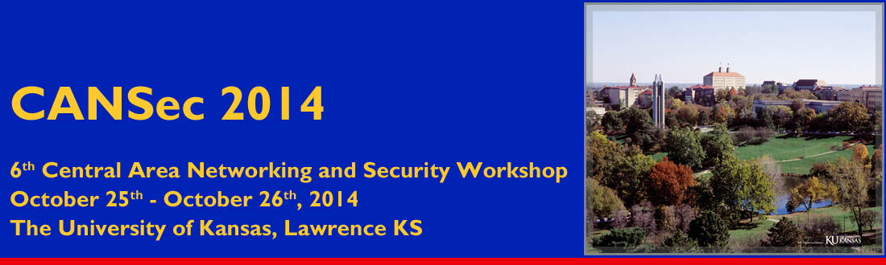

CANSec 2014 Student Travel Grant Application
Name: ________________________ Email address: ______________________________________
Institution: __________________________________________________________________________
Degree seeking and expected completion date: _____________________________________________
Name and email address of advisor: ______________________________________________________
Research background and interests:

Please indicate: (1) if you belong to any underrepresented minority group; (2) if you are submitting an abstract for oral or poster presentation along with this application; and (3) if you are participating the student cyber-defense competition.

Please email the application, along with an up-to-date CV, to cansecworkshop@gmail.com. Applications are due October 17th, 2014, and notifications will be made on October 20th, 2014.

